Leap Year Program:

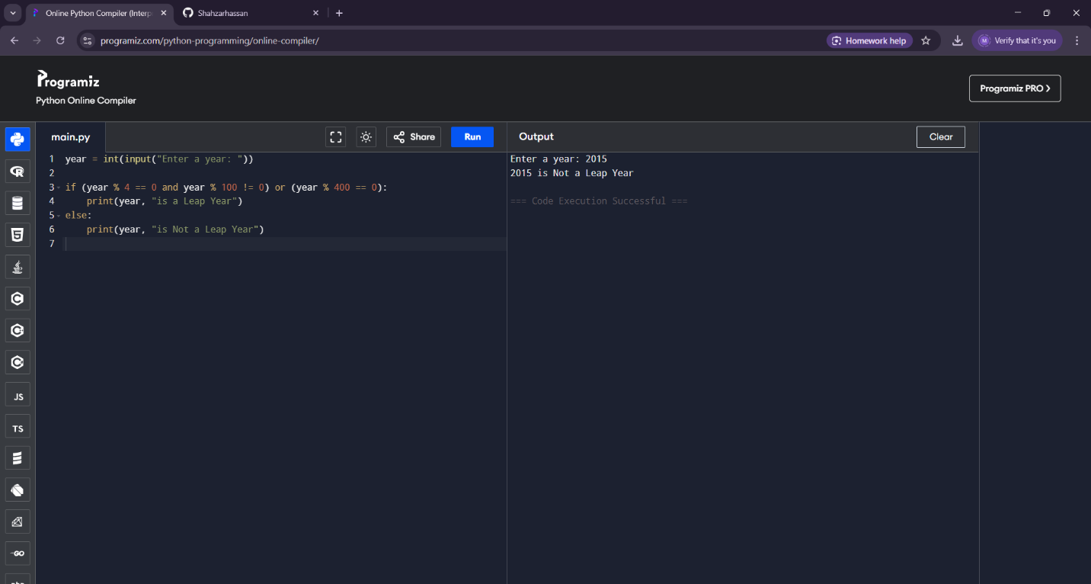

Grade program:

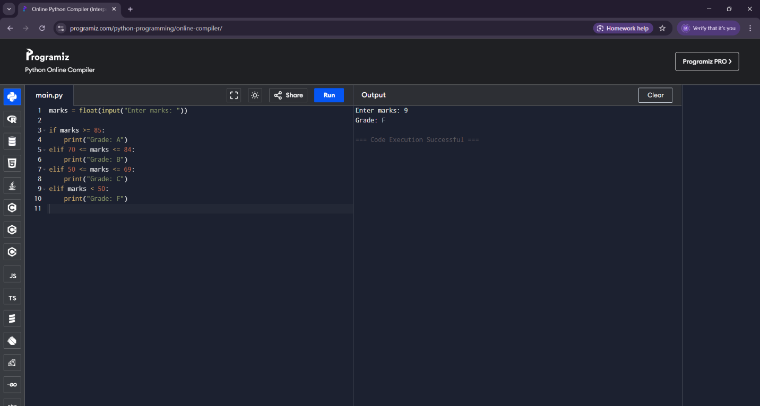

Activity 1:

**How can you break down the trip planning process into smaller, manageable tasks?**

**Decomposition**

* **Define the destination**: Murree
* **Budget planning**: Estimate travel, accommodation, food, and entertainment expenses.
* **Transport planning**: Decide on transportation (car, bus, etc.), book tickets or arrange vehicles.
* **Accommodation booking**: Research and book a hotel, guest house, or resort in Murree.
* **Packing**: Make a checklist of items to pack, including clothes, toiletries, and other necessities.
* **Route planning**: Plan the most convenient route and breaks during the trip.
* **Entertainment & Activities**: Decide what to do (sightseeing, hiking, etc.) and book any required tickets.
* **Contingency planning**: Prepare for unexpected situations (weather, road closures, etc.).

**2. What patterns can you identify from your past travel experiences?**

**Pattern Recognition**

* **Similar tasks**: Each trip involves booking transportation, accommodation, and planning activities.
* **Packing routine**: The same items are needed on every trip (clothes, personal hygiene items, medications).
* **Budget management**: Always need to estimate and track expenses for accommodation, transport, and meals.
* **Weather concerns**: Check the weather before departure and pack accordingly.
* **Route planning**: Familiarize with possible traffic conditions or road diversions before leaving.

**3. What are the essential elements to consider when planning a trip?**

**Abstraction**

* **Travel arrangements**: Decide on the mode of transport and book early.
* **Accommodation**: Ensure it’s near the points of interest and fits the budget.
* **Weather**: Plan for the season and climate in the destination area.
* **Activities**: Research local attractions, sightseeing, and events.
* **Health & safety**: Pack essentials like first aid kits, and check local health advisories or travel restrictions.

**4. How can you create a step-by-step plan to ensure a successful trip?**

**Algorithm Design**

**Step 1: Prepare Budget**

* Estimate travel costs.
* Allocate funds for accommodation, meals, transport, and entertainment.

**Step 2: Research**

* Select a place to stay.
* Look into transport options and book early.
* Research local activities and sights to visit.

**Step 3: Organize Essentials**

* Make a packing list based on the destination's weather and duration.
* Book any required tickets for attractions or events.

**Step 4: Set Travel Dates**

* Confirm all bookings (transport, accommodation, and activities).
* Check the weather forecast for your travel dates.

**Step 5: Execution**

* Ensure all travel documents are ready (ID, tickets, etc.).
* Pack in advance and leave at least 30 minutes earlier for the journey.

**Step 6: Backup Plan**

* Have a plan for emergencies, like road closures or weather changes.